AAW

AWS ADVANCED PROJECT-4

**Git Project**

ARAVIND G KUMAR

**Introduction:**

**Git** is a distributed version-control system for tracking changes in any set of files, originally designed for coordinating work among programmers cooperating on source code during software development. Its goals include speed, data integrity, and support for distributed, non-linear workflows.

* Create a repository in git hub.
* Create a new repo in the GitHub named new repo.

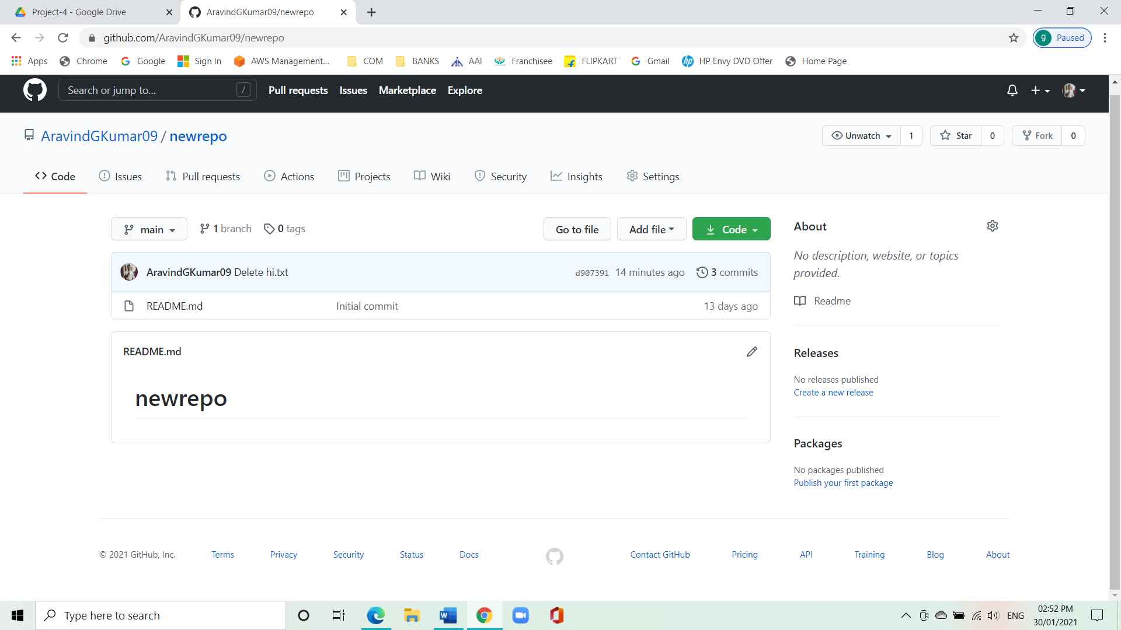

* Open git bash and clone the contents from remote repository.
* Create a new folder and call in git bash in the folder.

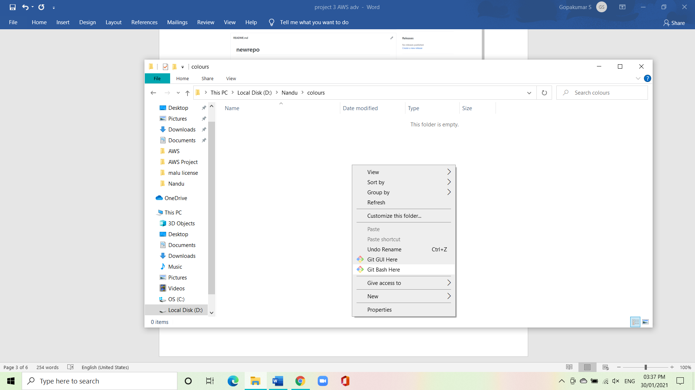

Follow the command:

Git init

Mkdir red

Git config –-global user.email (user email)

Git config –-global user.name (user name)

Git clone (paste the url of the repo)

Ls

Cd \newrepo

Touch test.txt

Ls

Git status

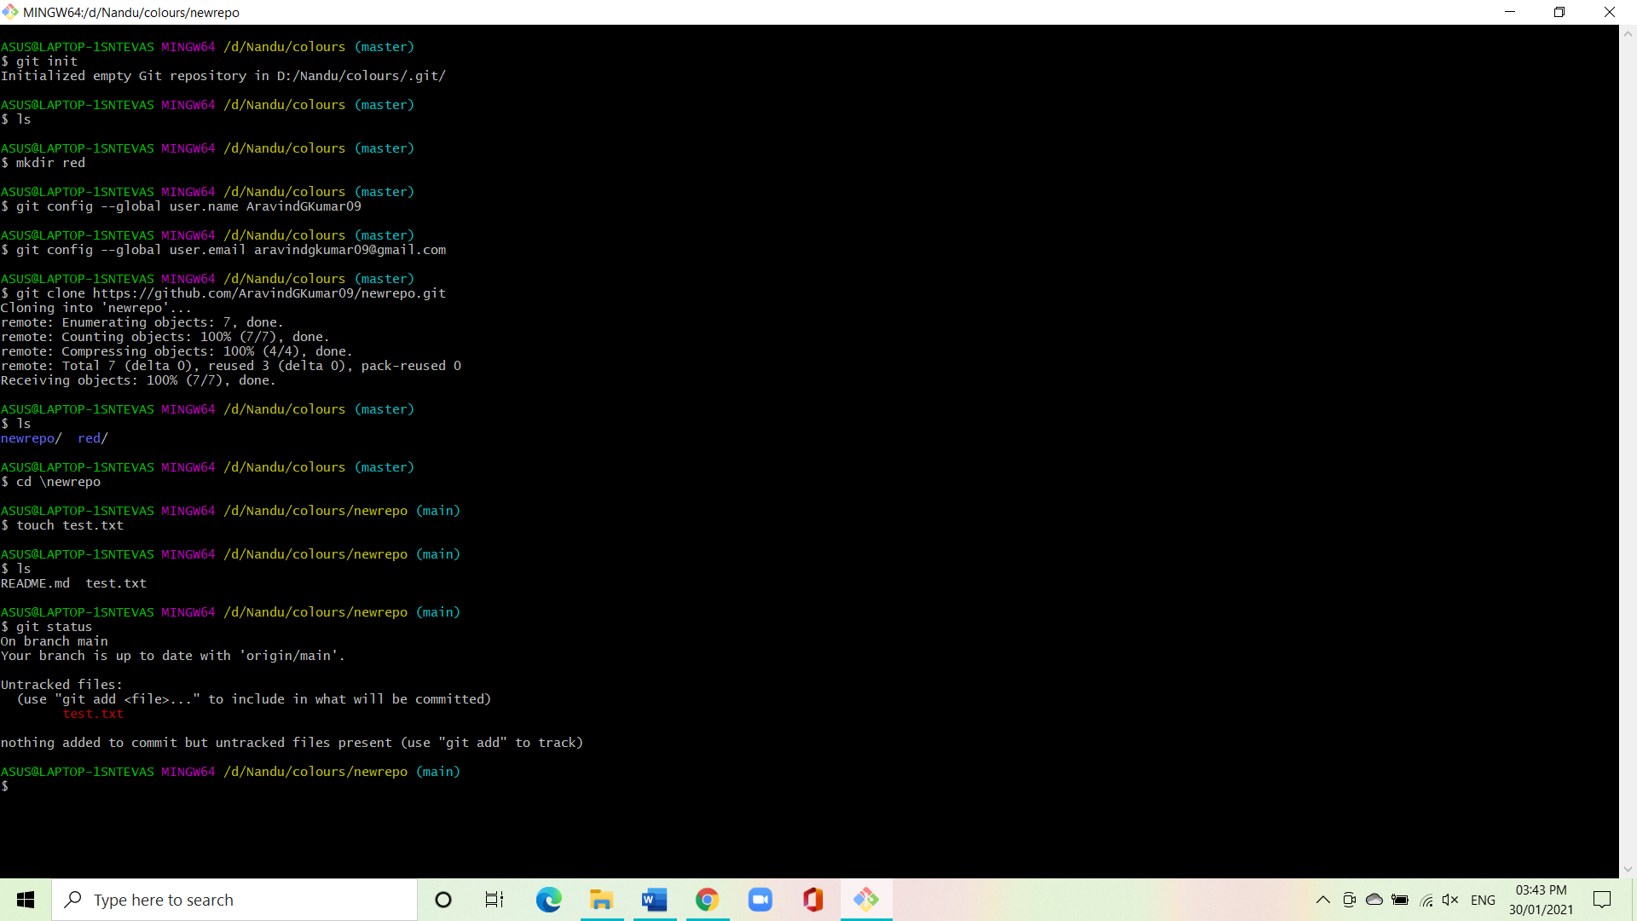

* Create a file in the local space and push it to the remote repository.

Follow the command:

Git add test.txt

Git status

Git commit -m “first commit” test.txt

Git status

Git push -u origin main

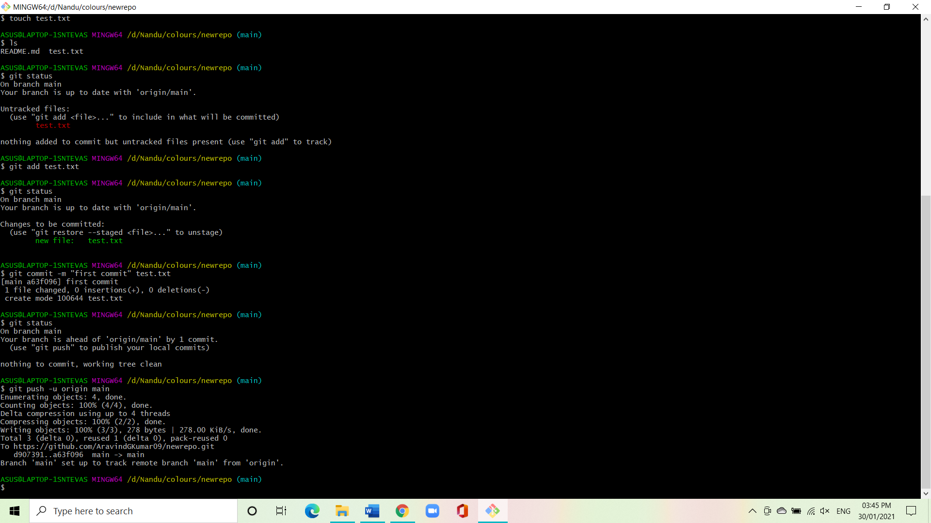

* Show the file in the remote repository.

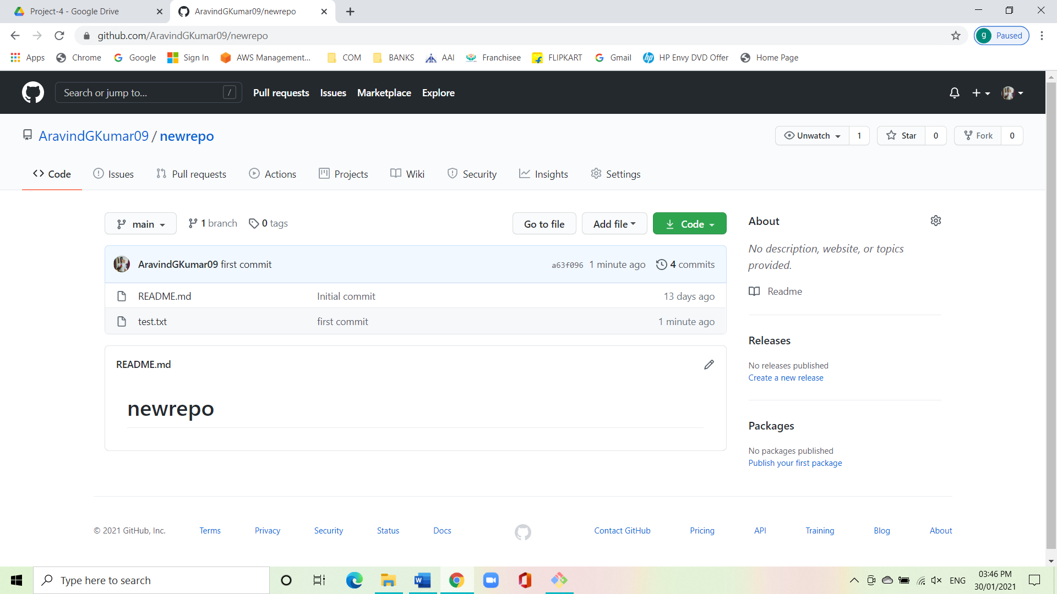

* Git branching and merging.

Git branch: to show branches

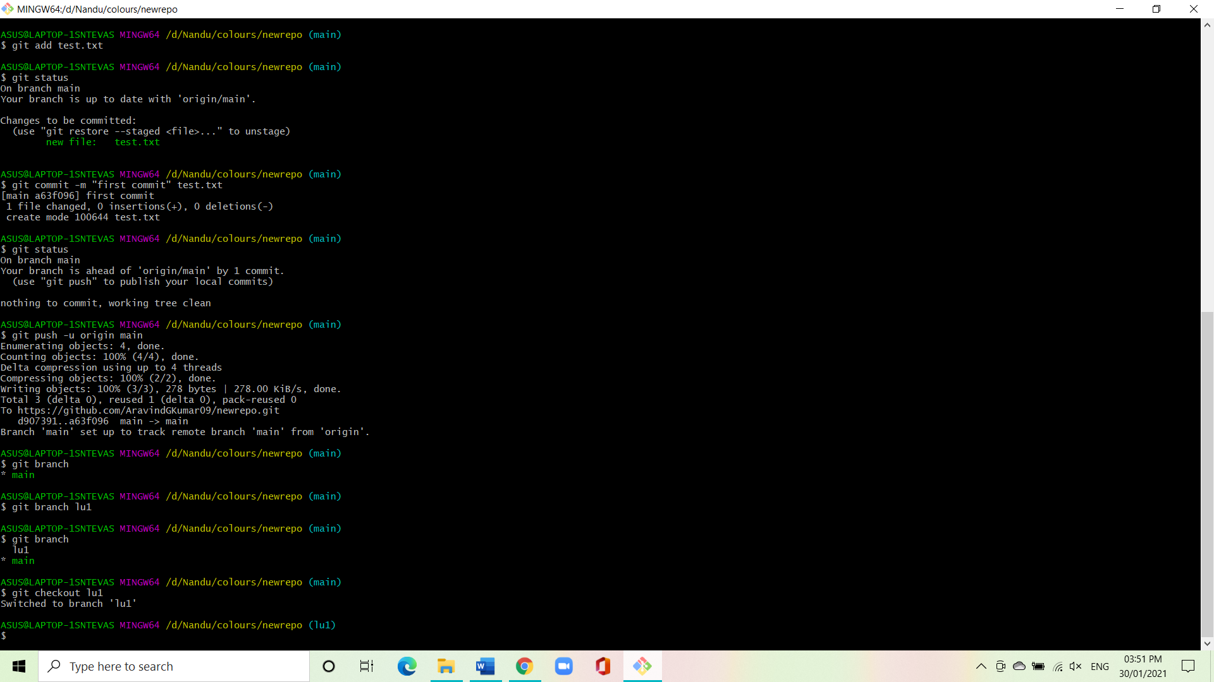

Git branch branch name: to create a branch



Git checkout branch name: switch to next branch



Git merge branch name: to merge the branches

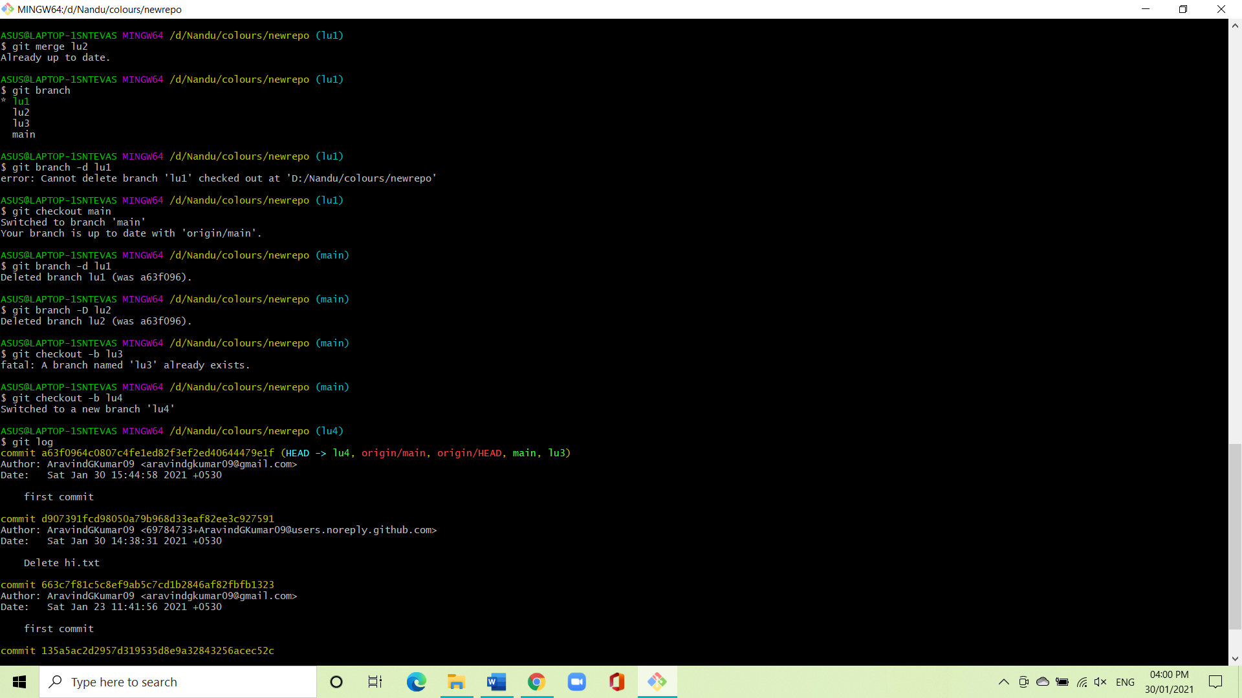

Git branch -d branch name: to delete the branch



Git branch -D branch name: deletes the branch and file

in it.



Git checkout -b branch name: adds a new branch



Git log: gives the details of the repository.

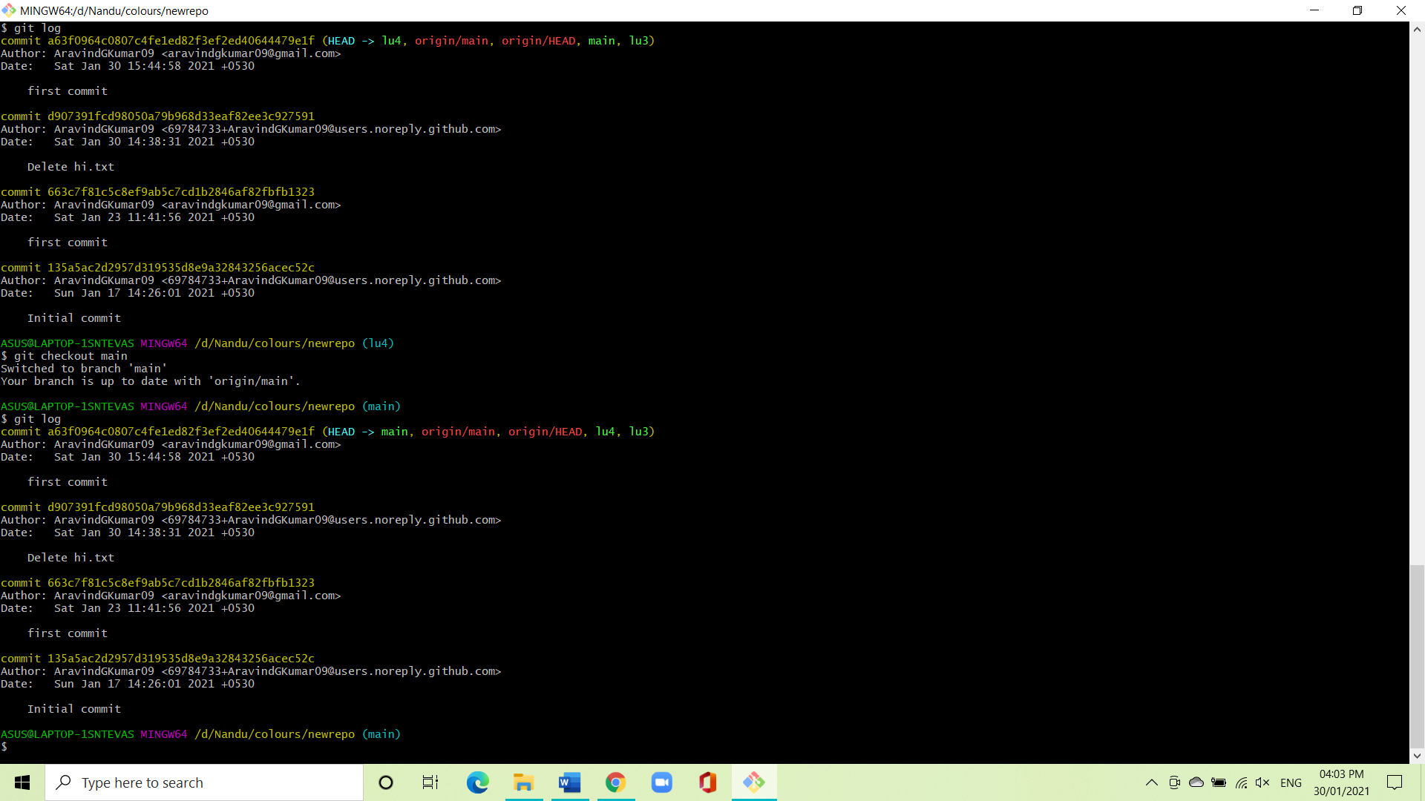

**Conclusion:**

We have successfully created a local repository and pushed it to the remote repository.